Përgjigjet:
1._________________________________________________________________

2.___________________________________________________________________________________

3._________________________________________________________________________________________________________________________________________________________________________________________________________________________________________________________________________________________________________________________________________________________________________________________________________________________________________________________________________________________________________________________________________________________________________________________________________________

4._____________________________________________________________________________________________________________________________________________________________________________________________________________________________________________________________

5._____________________________________________________________________________________________________________________________________________________________________________________________________________________________________________________________________________________________________________________________________________________________________________________________________________________________________________________________________________________________________________________________

Emri:_________________________ Data:__05.2015
Emri :________________ Data:__.05.2015
Titulli:_______________________________________________
Kush erdhi në klasë?
Kur erdhi nxënësi në klasën tonë?
Ku u ul nxënësi?
Çfarë shikonte ai ?
Pse ishte hutuar Afrimi?
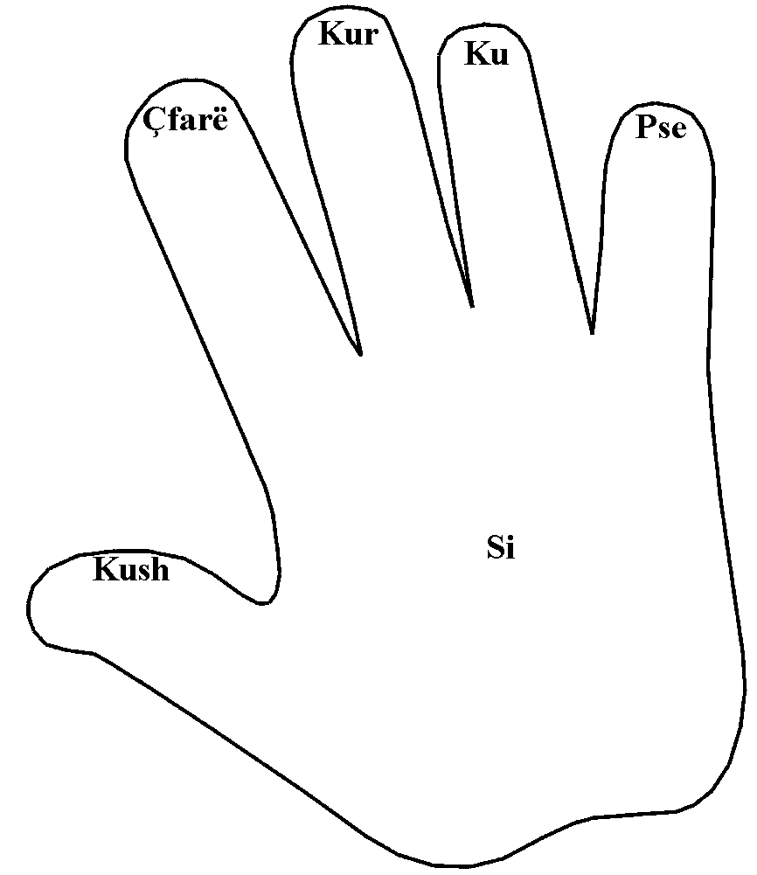
Si veproi mësuesi?

Nxjerrja e qëllimit : Qendra NJERIU MËSON

